**Question 1:**

// Program says welcome message to the console output

class Welcome {

public static void main(String[] args) {

System.out.println("Hi Abdul!");

System.out.println("Welcome to Programming World");

}

}

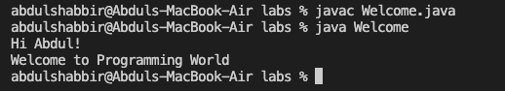

**Question 2:**

import java.text.DecimalFormat;

import java.util.Scanner;

/*

Program computes the average acceleration using the initial velocity, final velocity and time from console input.

*/

public class AverageAcceleration {

public static void main(String[] args) {

Scanner input = new Scanner(System.in);

System.out.print("Enter v0, v1, and t: ");

float initialVelocity = input.nextFloat();

float finalVelocity = input.nextFloat();

float time = input.nextFloat();

input.close();

double acceleration = (finalVelocity - initialVelocity) / time;

DecimalFormat decimalFormat = new DecimalFormat("#.####");

System.out.println("The average acceleration is " + decimalFormat.format(acceleration));

}

}

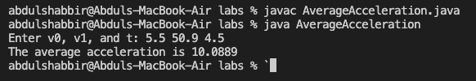

**Question 3:**

import java.util.Scanner;

import java.text.DecimalFormat;

// Program computes the BMI of a person by using the weight (in pounds) and height (in inches) from console input

public class BMI {

public static void main(String[] args) {

Scanner input = new Scanner(System.in);

final double kilogramsPerPound = 0.45359237;

final double metersPerInch = 0.0254;

System.out.print("Enter weight in pounds: ");

double weightInPounds = input.nextDouble();

System.out.print("Enter height in inches: ");

double heightInInches = input.nextDouble();

input.close();

double weightInKilograms = weightInPounds * kilogramsPerPound;

double heightInMetres = heightInInches * metersPerInch;

double bodyMassIndex = weightInKilograms / (heightInMetres * heightInMetres);

DecimalFormat decimalFormat = new DecimalFormat("#.####");

System.out.println("BMI is " + decimalFormat.format(bodyMassIndex));

}

}

